Andersson Jacob, Johansson Tim, Wikström Leo, Åsbrink Anton

2018-04-23

Interaction Diagram

Assigment in the course PA1435 Objektorienterad Design

|  |  |  |  |
| --- | --- | --- | --- |
| **Author Name** | **Personal identity Number** | **Thinking** | **Writing** |
| Andersson Jacob | 960221-8134 | 10% | 0% |
| Johansson Tim | 970718-3472 | 30% | 15% |
| Wikström Leo | 970523-6611 | 40% | 60% |
| Åsbrink Anton | 970428-0135 | 20% | 25% |

This diagram is to show the interactions of different use cases and the functions to achieve the desired effect. All functions are accessed through an interface screen depending on the functions. This show the first iteration and the minimal viable product.

**Priority List:**

* Add good, Priority: 7
* Move good, Priority: 7
* Select good, Priority: 7
* Select Truck, Priority: 6
* Remove Good, Priority: 6
* Track Trucks, Priority: 5
* Direct truck, Priority: 4
* Select warehouse, Priority: 4

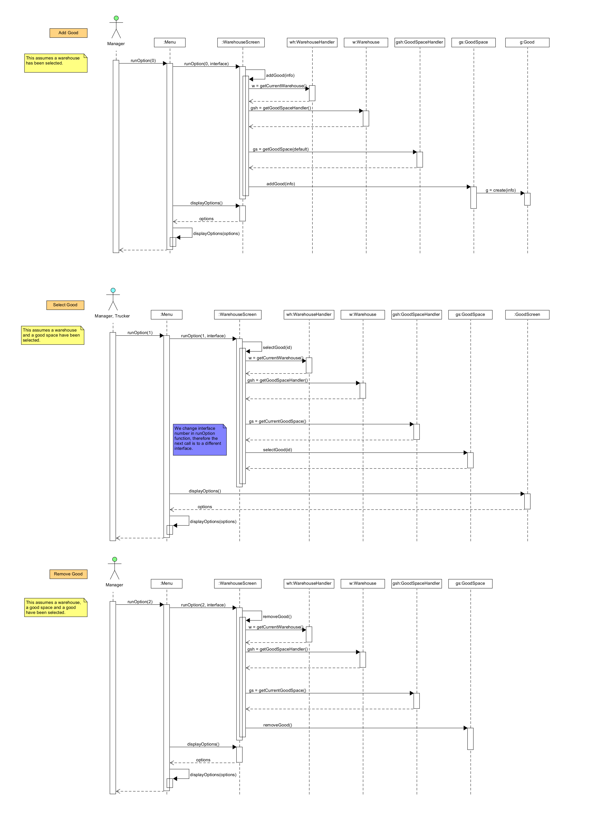The goods use cases are of highest priority since what is a warehouse without goods. The functions for changing goods are behind several compositions and handlers such as warehouse holding good space and good space holding goods.

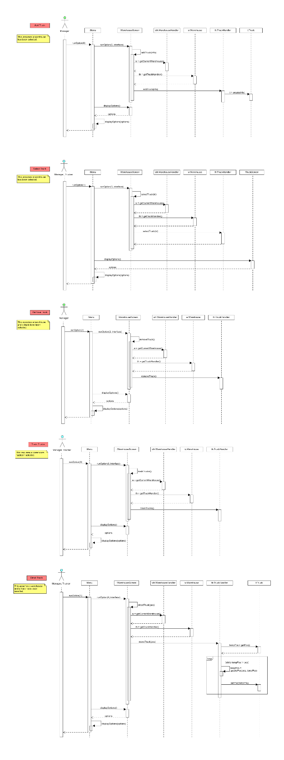The truck use cases function can be accessed through warehouse. The trucks are needed for the movement of goods. They are important for the core function of the programm.

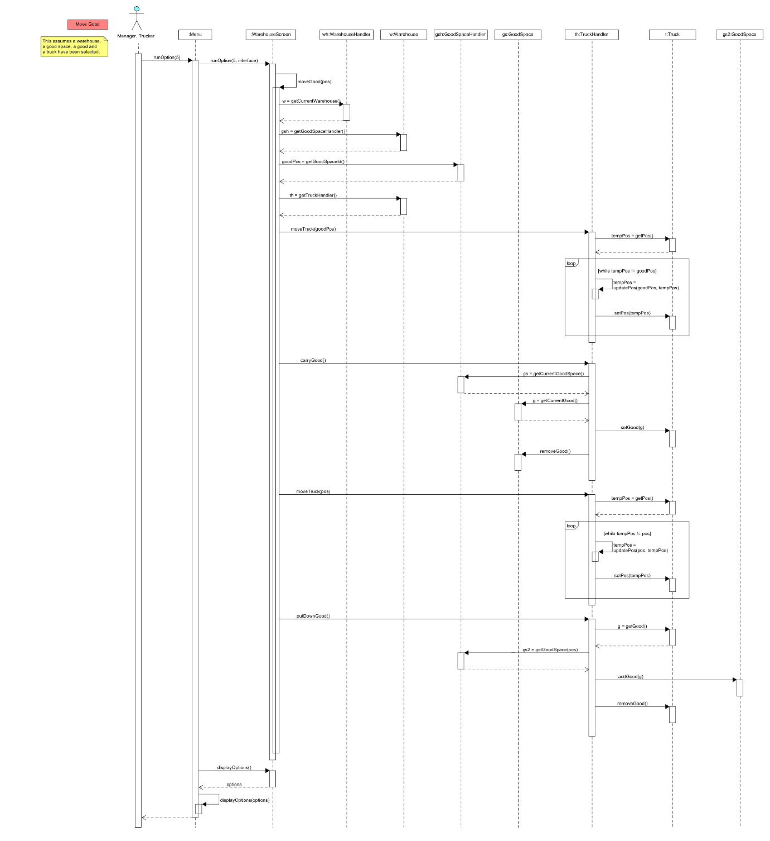The Move Good function is a complex one since we have to communicate to the trucks what good to take and where to take it. For that we have to access and retrieve information from goodspace, goods and the truck.

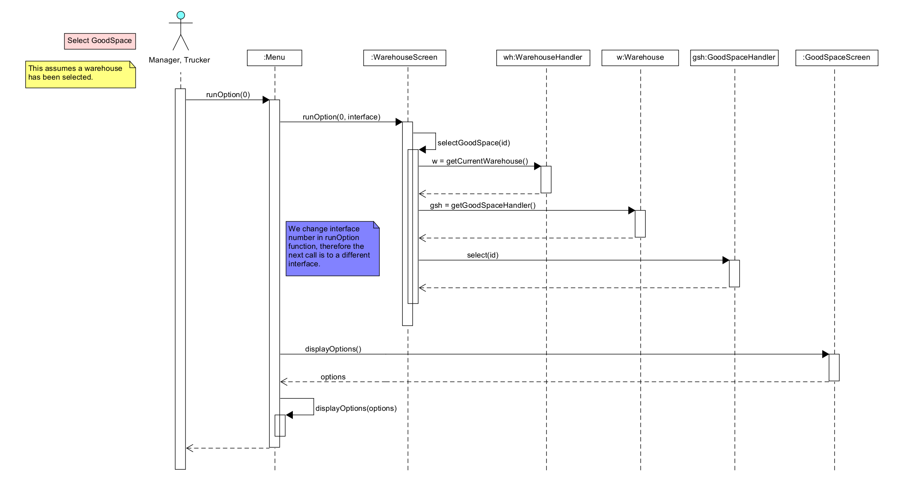

Goodspace is a position that holds several goods and works as a position for any good.

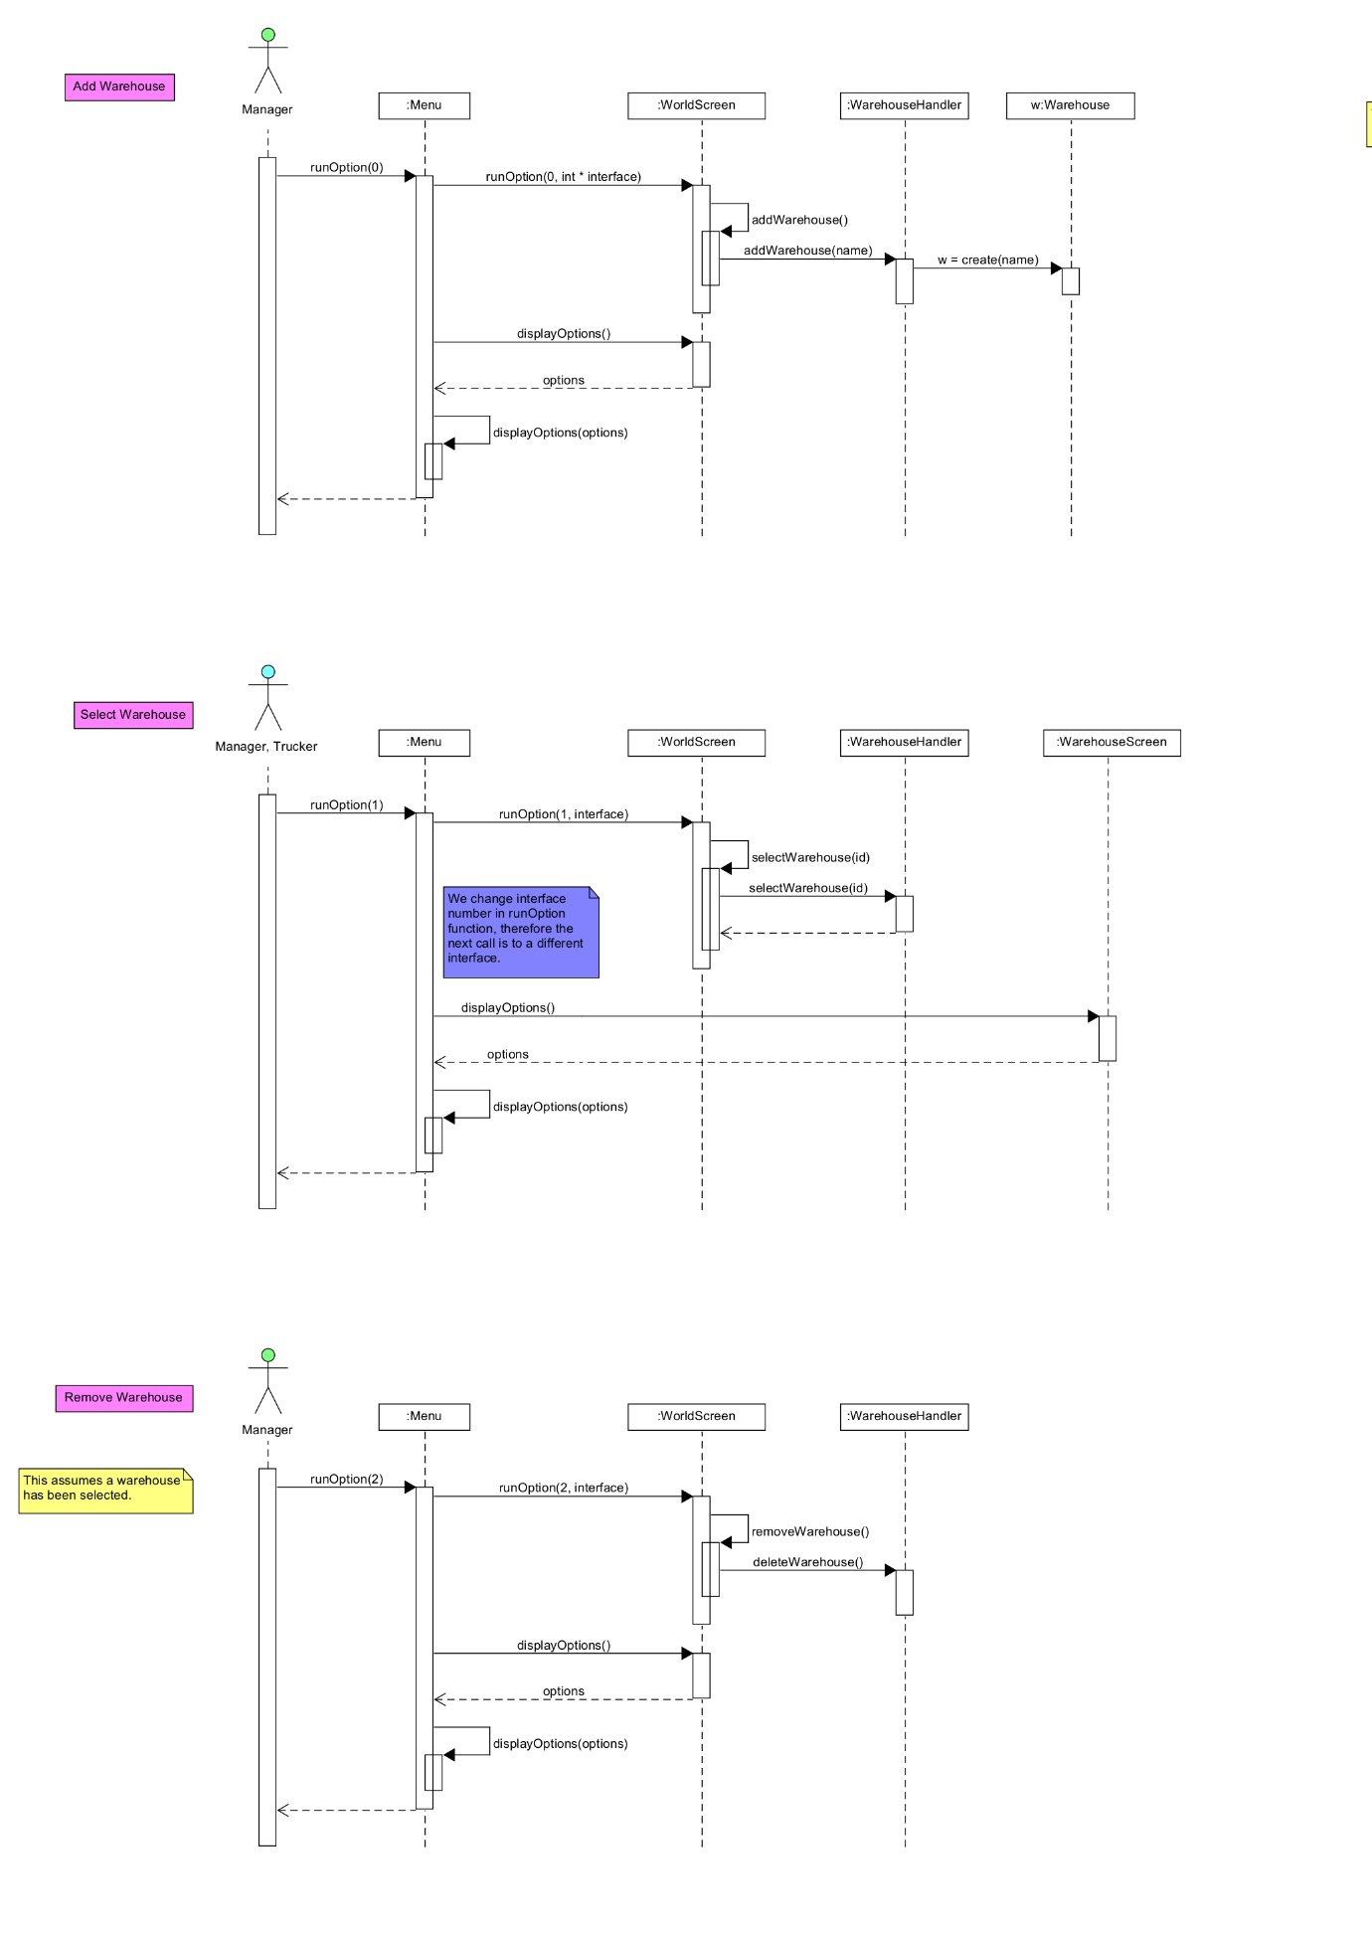The warehouse functions are vital if there are multiple warehouses. If they close, open and most importantly if to select a warehouse for command.